**Recruiting Advertising Strategy**

**Background**

The Whitman School of Management launched an Internet recruiting campaign from February 2011 through December 2014, using Google ads and Delta Airlines flight magazine advertisements. An assessment of opportunities and results is now necessary to establish the direction for a campaign one year from today.

**Resources**

Use Google Analytics to examine the Whitman Graduate Programs Internet marketing campaigns. All data can be accessed via Google Analytics. If you have any questions, please send me an email.

**Assignment**

**What’s due:**

Submit an advertising analysis **before the live class in week 6**. Suggested length is five pages, but should not exceed ten pages, single-spaced, 12-point font.

Use Google analytics to analyze the data to identify patterns and opportunities. Your goal is to recruit the best United States students, measured by GMAT scores, but you are limited to a budget of $100,000. The budget must cover advertising costs, but no Whitman administration costs. The campaign starts one year from today.

This is a group assignment; each student should upload a copy of the assignment to the Learning Management System. The paper must be a Microsoft Word document. Name the file HW2_Team# where # is your team number. Be sure to include the names of everyone on the team on the first page of the paper. Late assignments will not be accepted. Failure to follow directions will be penalized.

**Outline and grading criteria:**

1. **What were the time frames for each marketing campaign?   
   How much was spent on each campaign?   
   What was the effectiveness of previous campaigns? (40%)**
   1. **Whitman.syr.edu**
   2. **MBA Marketing – iMBA**
   3. **MBA Marketing – Full-time**
   4. **Delta (cost of one-month quarter page ad was $10,000)**

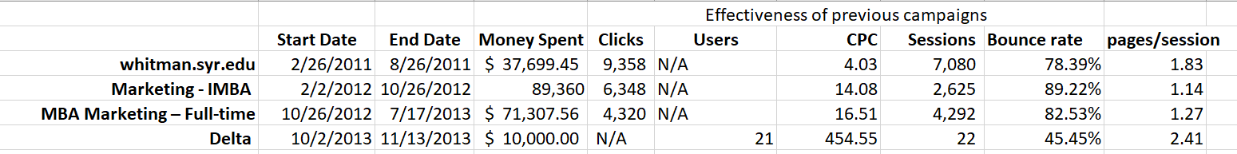

1. **Create a prediction of cost per click and a prediction of advertising cost per student for Google Ads for next year. Use either the prediction technique or Excel’s forecast option.   
   Do not include Delta. If using the forecast option, assume the years below.   
   Number of students recruited from the advertisements is listed below. (10%)**
   1. **whitman.syr.edu (2011 – 50 students enrolled)**
   2. **MBA Marketing – iMBA (2012 – 24 students enrolled)**
   3. **MBA Marketing – Full-time (2013 – 15 students enrolled)**

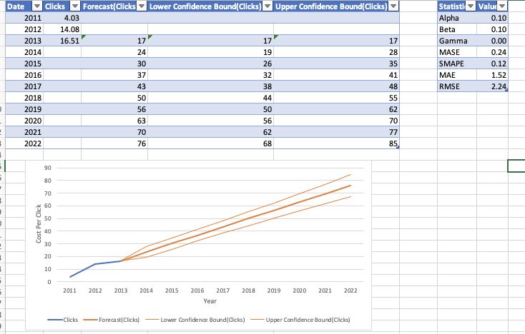

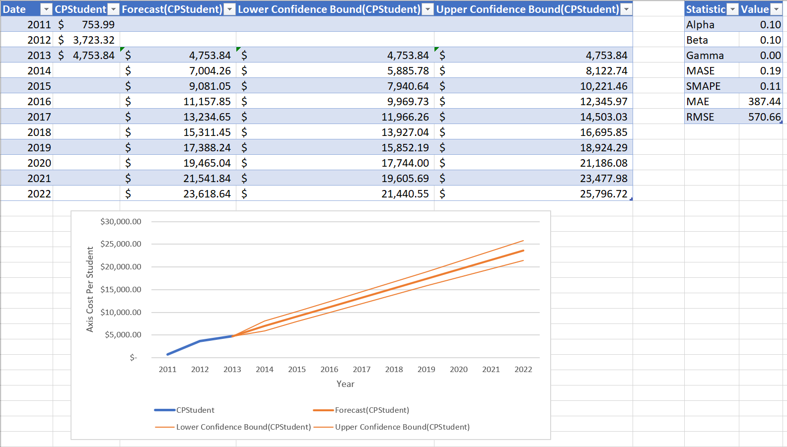

1. **Identify the key aspects of a United States campaign for next year (20%)**  
   **a. In which geographic region, states, or cities would you advertise? Why?**

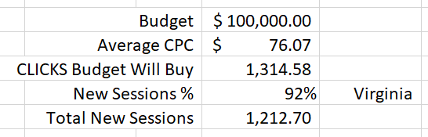

Virginia has an extremely high percentage of New Session Rate. With a budget of $100,000 and a forecasted cost of $76.07 per click we will only be able to afford 1,314 clicks during our campaign. With Virginia having a high New Session Rate of 92%, it means, theoretically we should be able to expect to generate roughly 1,213 new sessions (92% of our 1,314 clicks). Virginia seems like it would offer a very powerful “bang for our buck” or ROI.

**b. What keywords would you use? Why?**

First, we determined which campaigns were most successful at generating clicks. When taking into account the average clicks per day generated between campaigns, the whitman.syr.edu campaign generated 52 clicks per day whereas the second most successful campaign, the Marketing-IMBA campaign, only generated 24 clicks per day on average, half that of whitman.syr.edu. Therefore, since the whitman.syr.edu campaign was so successful we decided to mimic those successes for our 2022 campaign.

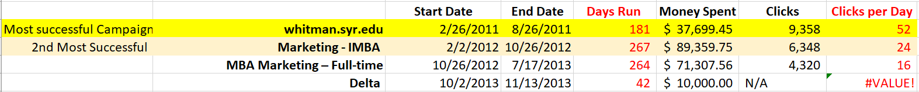

The keyword that generated the most clicks in the whitman.syr.edu campaign was “MBA”. “MBA” generated 96.67 of the clicks referencing a keyword. Because the keyword data for this campaign only accounted for 300 clicks in total (possible dirty data), we also used the Marketing-IMBA campaign for reference and the keyword, “MBA”, was the 2nd most impactful keyword of that campaign. Therefore, we feel comfortable that “MBA” is a good keyword to generate clicks.



**c. Which days of the week and what time of day would you advertise? Why?**

We found that Sunday was the day of the week that generated the most new users for the whitman.syr.edu campaign. To solidify our trust that this would be the best day to target potential new students we found that Sunday was also the day of the week that generated the most new users for the Marketing-IMBA campaign.

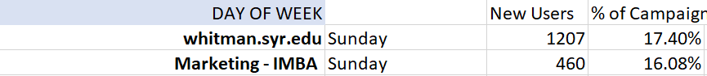

Lastly, for time of day, we found that 9pm-10pm was the hour that resulted in the highest percentage of new users during the whitman.syr.edu campaign, followed by the 8pm and 10pm hours. To again solidify our choosing of 9pm we referenced the results of the Marketing-IMBA campaign and found a similar time of day of 8pm being the hour that resulted in the highest percentage of new users during that campaign. Therefore, we decided to trust the results of the most successful campaign, whitman.syr.edu and choose 9pm-10pm for our 2022 campaign.

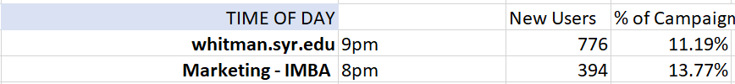

Considering that our budget only allows for 4 clicks per day if we were to run this campaign for the full year of 2022, we believe targeting the state of Virginia on Sundays, between the hour of 9-10pm using the keyword MBA would attract the most potential students to our site.

1. **How would you measure performance of your decisions after implementation? (20%)**

The simplest form of measurement for tracking the performance of an AdWords campaign is using the traffic-based metrics that are available in the standard campaign dashboard. There are lots of metrics that can be measured at the keyword, advert, ad group and campaign level to indicate performance and these include impressions, clicks, click-through rate, quality score and average cost per click.

The most important metric would be enrollment! Here are a couple of KPIs we could use.

Admissions/Enrollment KPIs, students are the lifeblood and purpose of an educational institution - it's key to understand how they are passing through the organization. Admin Rate, the admin rate is a KPI which measures and informs management of the percentage of those who applied to the university and who were offered acceptance to study.

1. **What other factors or considerations are important? What other data would help in developing an Internet advertising strategy, if you could collect it? (10%)**

Other factors or considerations that are important are that only 3% of keywords were applied to clicks for the Whitman.syr.edu campaign. We noted that this campaign was the most successful, however with such a limited amount of the clicks being mapped to keywords, it is hard to gain accurate insight as to which keywords are attributed to the success of the campaign. We would want to conduct an AB Test before sticking to our keyword choice. Other considerations include is google the best platform for marketing or would another platform be better suited for marketing to MBA candidates (e.g. Facebook, Instagram).

Other data that would help in developing an internet advertising strategy include:

* Age and gender demographics
* GMAT scores linked to potential candidates
* Other schools candidates are looking at
* The reason candidates are looking at higher education (e.g. job promotion)